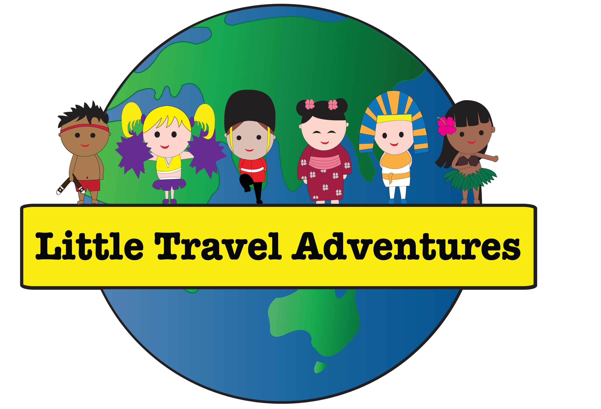
Little Travel Adventures

Child Safe Policy
All children whilst participating in Little Travel Adventures programs have a right to feel safe, protected and included.
This policy is part of our organisation’s ongoing commitment to protecting the children in our care from harm and abuse. It:
- outlines the child safe practices our organisation has put in place to minimise the risks to child safety whilst participating in our classes
- sets out what is required from staff, including volunteers and others who interact with our organisation, so they know what is expected from them to keep children safe.

Our commitment to child safety
At Little Travel Adventures we commit to the safety and wellbeing of every child in our care. Please read our Statement of Commitment to Child Safety, which is available on our website www.littletraveladventures.com.au, or can be emailed to you at your request.
Our organisation ensures services and activities are inclusive of all children, including children with diverse needs.

Scope and audience for this policy
The policy applies to all staff and volunteers working for Little Travel Adventures when taking part in any activities, services and events that involve children.

Responsibilities for children’s safety
Everyone in our organisation is expected to carry out the requirements specific to their role to keep children safe. This includes:
- upholding our organisation’s commitment to child safety
- reading, signing and upholding the behaviours set out in our Child Safe Code of Conduct
- meeting requirements across all other child safe policies and procedures, including child safe recruitment practices and risk management
- taking part in our regular reviews of our child safe documents
- reporting all breaches of our policies or any allegations of child harm or abuse, and meeting all external reporting obligations
- completing all child safe training.
Please contact Kristy Filewood with any of your child-safety related questions or concerns.

Active participation of children, families and communities
- All our child-related policies and procedures are easily accessible on our website and offline by request for everyone who requests our services or events, including staff, children, parents, carers and community members.
- Staff, Parents and Children from diverse backgrounds are respected and supported and encouraged to provide feedback at any time, either via the child care centre, or directly with Little Travel Adventures.
- We provide opportunities for child care centres to provide feedback to our management, on what makes them and the children feel safe, supported and included.

Definitions of harm and abuse

General definitions
Psychological abuse (also known as emotional abuse)
This includes bullying, threatening and abusive language, intimidation, shaming and name calling, ignoring and isolating a child, and exposure to domestic and family violence.
Physical abuse
This includes physical punishment, such as pushing, shoving, punching, slapping and kicking, resulting in injury, burns, choking or bruising.
Sexual abuse
This includes the sexual touching of a child, grooming, and production, distribution or possession of child abuse material.
Grooming
This is a process where a person manipulates a child or group of children and sometimes those looking after them, including parents, carers, teachers and leaders. They do this to establish a position of ‘trust’ so they can then later sexually abuse the child.
Misconduct
This is inappropriate behaviour that may not be as severe as abuse, but could indicate that abuse is occurring and would often be in breach of an organisation’s Child Safe Code of Conduct. This could include showing a child something inappropriate on a phone, having inappropriate conversations with a child or an adult sitting with a child on their lap.
Lack of appropriate care
This includes not providing adequate and proper supervision, nourishment, clothing, shelter, education or medical care.

What the policy covers

Social media use and online communication
Staff and volunteers must never communicate privately with children online or on social media. All communication is to be directed to the centre director or staff in charge of organising incursions.

Photography and the use of images
Little Travel Adventures staff will not take photos or videos of the children without prior permission of parents or carers. Only photos or videos posted on social media by childcare centres (who have received appropriate approval) will be shared on our social media channels. It is unacceptable for staff or volunteers to take photos or videos of children, other than their own, on personal devices, or to share images without permission.

Physical contact
Physical contact with children should be kept to a minimum. Everyone involved in the organisation is expected to have healthy physical boundaries with children.

Gifts and benefits
Staff and volunteers must never give gifts to children, or bestow benefits of any kind to a child, unless they have direct permission from the child’s parents or carers.

Secondary employment
Staff members must declare any secondary employment and make sure there are no conflicts of interest associated with the employment.

Out of hours contact with children
Professional boundaries with the children in our care must be maintained at all times, with no out-of-hours contact after the service has been provided.

Illness and injury management
Injuries must be reported to the first aid officer at the centre for them to follow correct protocol.

Reporting requirements for different types of concerns or incidents
Any internal or external complaints or reports can be made in writing to kristy@littletraveladventures.com.au

Other related child safe documents

Little Travel Adventures has a range of other key documents that relate to child safety. These can be accessed at www.littletraveladventures.com.au, and include:

Statement of Commitment to Child Safety
Our public commitment to prioritising child safety across our organisation.

Child Safe Code of Conduct
Guides the day-to-day behaviours of adults interacting with children at the organisation.

Child Safe Recruitment, Induction and Training Policy
Sets out what is involved in the recruitment process and the procedures to be followed before a person is considered for a role at the organisation. This includes the verification of their Working with Children Check. It also outlines what is involved in the induction process for new recruits and any further training requirements.

Child Safe Risk Management Plan
Describes the specific risks at the service that could affect children's safety and identifies the protective strategies used to lower each risk.

Publication, communication and engagement
Our Child Safe Policy and other child safe documents can be found on our website www.littletraveladventures.com.au. Anyone involved in our community can request a copy via email at any time.

Related legislation, regulations and standards
Little Travel Adventures has to understand and comply with a number of NSW child protection laws and schemes. These include:
- NSW Child Safe Scheme
- Children’s Guardian Act 2019
- Child Protection (Working with Children) Act 2012
- Child Protection (Working with Children) Regulation 2013
- Children and Young Persons (Care and Protection) Act 1998

Next review date
2/02/2026, or earlier if there are any critical incidents

