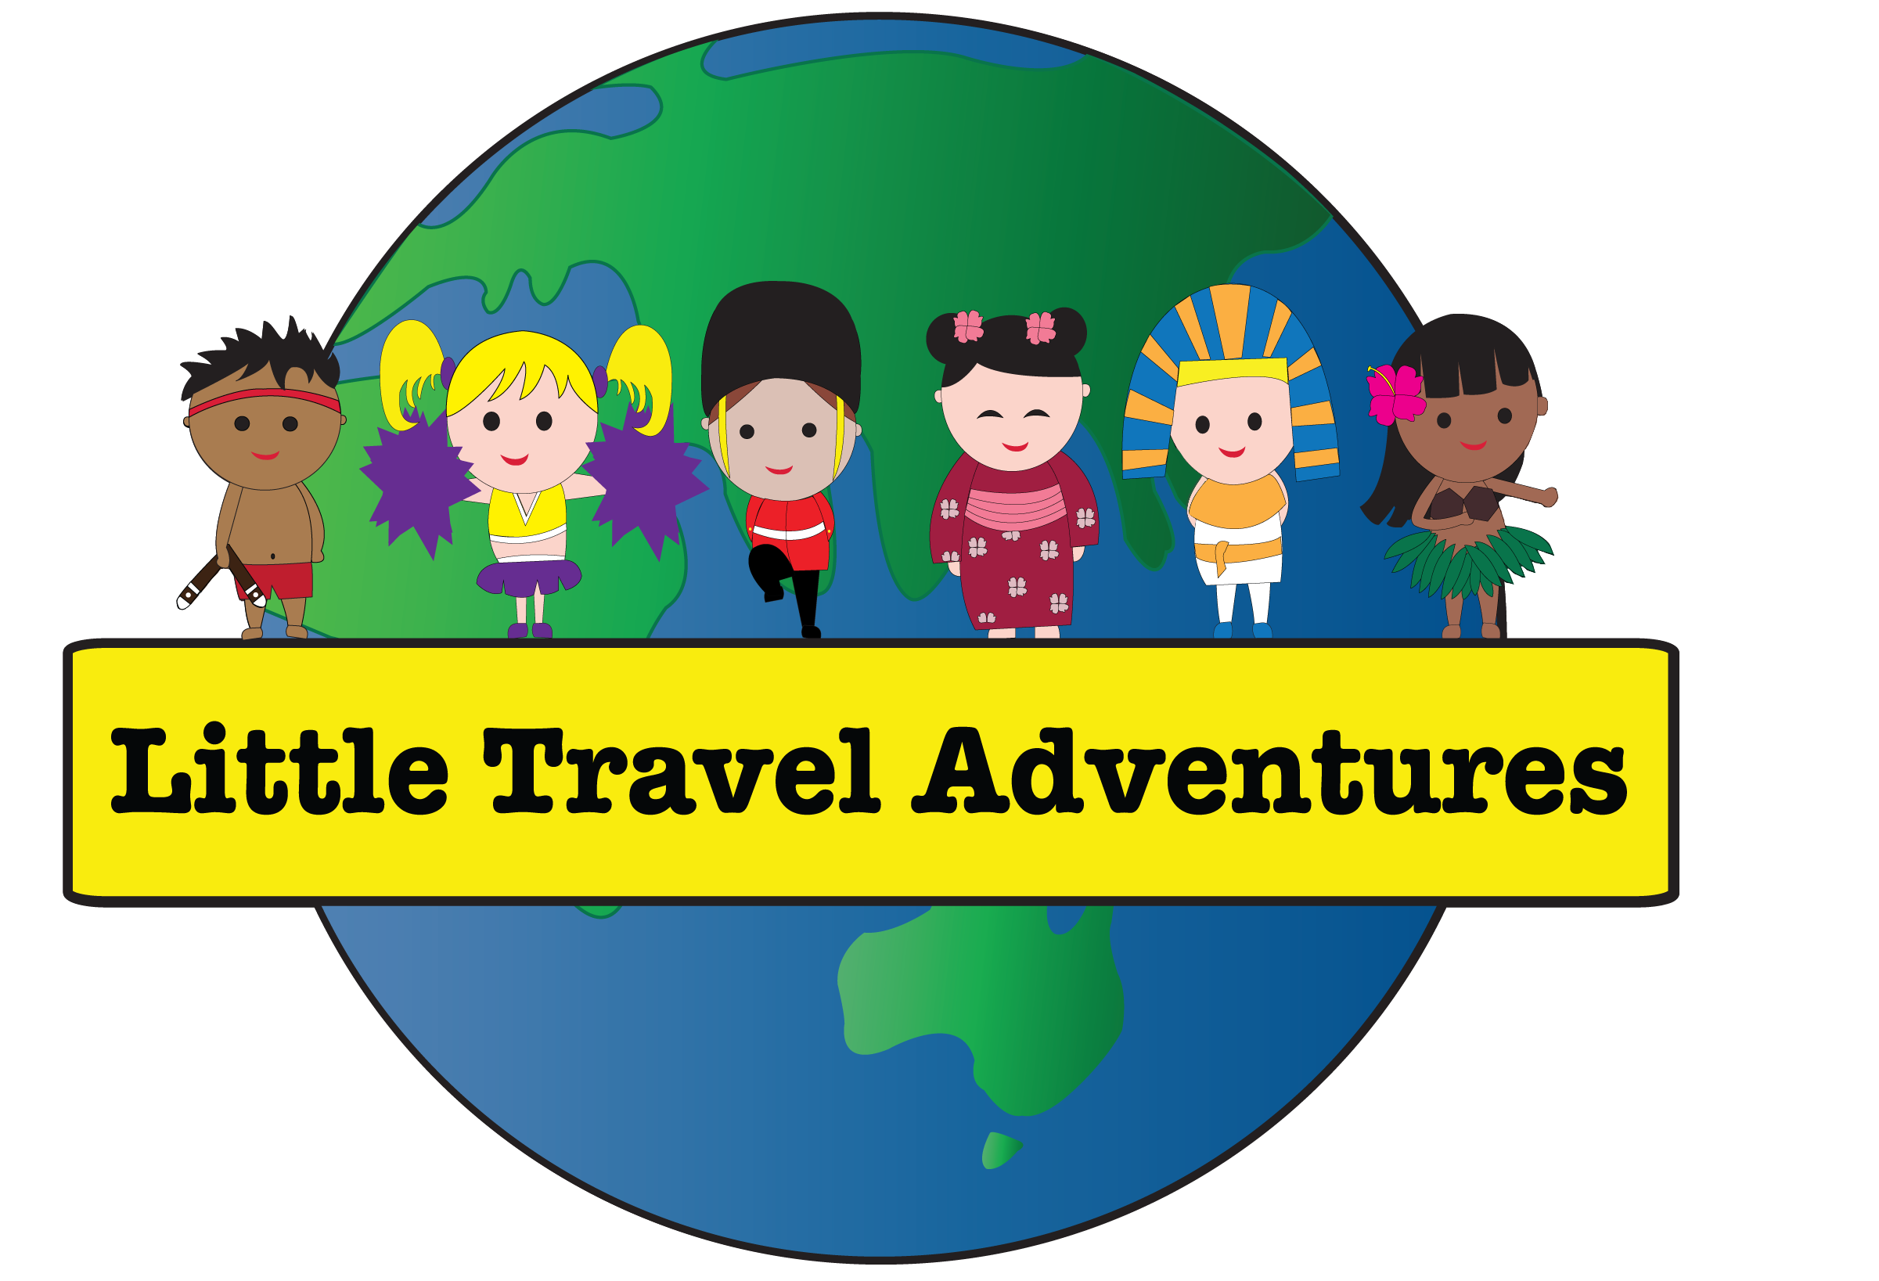

Little Travel Adventures

**Child Safe Reporting Policy**

Purpose of the policy

This policy sets out our organisation’s policy on child safe reporting and complaint handling.

Everyone in our organisation must:

* know **what** to report, **who** to report to and **how** to report
* report any concerns about the safety or welfare of a child or young person immediately
* ensure the safety and wellbeing of the child is paramount when responding to a disclosure or allegation about a child being harmed or at risk.

Our reporting practices will be regularly reviewed and updated to make sure they remain effective and comply with legislation.

## Definitions of harm and abuse

### General definitions

Psychological abuse (also known as emotional abuse)   
This includes bullying, threatening and abusive language, intimidation, shaming and name calling, ignoring and isolating a child, and exposure to domestic and family violence.

Physical abuse  
This includes behaviours such as pushing, shoving, punching, slapping, kicking and unauthorised use of restraint.

Sexual abuse   
This includes the sexual touching or sexual assault of a child, grooming, and production, distribution or possession of child abuse material.

**Grooming**  
This is a process where a person manipulates a child or group of children and sometimes those looking after them, including parents, carers, teachers and leaders. They do this to establish a position of ‘trust’ so they can then later sexually abuse the child.

**Misconduct**   
This is inappropriate behaviour that may not be as severe as abuse but could indicate that abuse is occurring and would often be in breach of an organisation’s Child Safe Code of Conduct. This could include showing a child something inappropriate on a phone, having inappropriate conversations with a child or an adult sitting with a child on their lap.

**Lack of appropriate care**  
This includes not providing adequate and proper supervision, nourishment, clothing, shelter, education or medical care.

Reportable conduct definitions

[*Children’s Guardian Act 2019*](https://legislation.nsw.gov.au/view/html/inforce/2022-02-01/act-2019-025?query=VersionSeriesId%3D%222e8ac990-120d-4ed0-bc2b-35556e5bc3ec%22+AND+VersionDescId%3D%22c8f75804-c7dc-4cd9-b7ca-d7d46643f2f5%22+AND+PrintType%3D%22act.reprint%22+AND+(VersionDescId%3D%22c8f75804-c7dc-4cd9-b7ca-d7d46643f2f5%22+AND+VersionSeriesId%3D%222e8ac990-120d-4ed0-bc2b-35556e5bc3ec%22+AND+PrintType%3D%22act.reprint%22+AND+Content%3D(%22Child+Safe+Scheme%22))&dQuery=Document+Types%3D%22%3Cspan+class%3D%27dq-highlight%27%3EActs%3C%2Fspan%3E%2C+%3Cspan+class%3D%27dq-highlight%27%3ERegulations%3C%2Fspan%3E%2C+%3Cspan+class%3D%27dq-highlight%27%3EEPIs%3C%2Fspan%3E%22%2C+Search+In%3D%22%3Cspan+class%3D%27dq-highlight%27%3EAll+Content%3C%2Fspan%3E%22%2C+Exact+Phrase%3D%22%3Cspan+class%3D%27dq-highlight%27%3EChild+Safe+Scheme%3C%2Fspan%3E%22%2C+Point+In+Time%3D%22%3Cspan+class%3D%27dq-highlight%27%3E01%2F02%2F2022%3C%2Fspan%3E%22#sec.20) defines reportable conduct as:

* a sexual offence
* sexual misconduct
* ill-treatment of a child
* neglect of a child
* an assault against a child
* an offence under s 43B (failure to protect) or s 316A (failure to report) of the Crimes Act 1900
* behaviour that causes significant emotional or psychological harm to a child.

The definitions of harm and abuse listed below are based on those in [part 4, section 20](https://legislation.nsw.gov.au/view/html/inforce/2022-02-01/act-2019-025?query=VersionSeriesId%3D%222e8ac990-120d-4ed0-bc2b-35556e5bc3ec%22+AND+VersionDescId%3D%22c8f75804-c7dc-4cd9-b7ca-d7d46643f2f5%22+AND+PrintType%3D%22act.reprint%22+AND+(VersionDescId%3D%22c8f75804-c7dc-4cd9-b7ca-d7d46643f2f5%22+AND+VersionSeriesId%3D%222e8ac990-120d-4ed0-bc2b-35556e5bc3ec%22+AND+PrintType%3D%22act.reprint%22+AND+Content%3D(%22Child+Safe+Scheme%22))&dQuery=Document+Types%3D%22%3Cspan+class%3D%27dq-highlight%27%3EActs%3C%2Fspan%3E%2C+%3Cspan+class%3D%27dq-highlight%27%3ERegulations%3C%2Fspan%3E%2C+%3Cspan+class%3D%27dq-highlight%27%3EEPIs%3C%2Fspan%3E%22%2C+Search+In%3D%22%3Cspan+class%3D%27dq-highlight%27%3EAll+Content%3C%2Fspan%3E%22%2C+Exact+Phrase%3D%22%3Cspan+class%3D%27dq-highlight%27%3EChild+Safe+Scheme%3C%2Fspan%3E%22%2C+Point+In+Time%3D%22%3Cspan+class%3D%27dq-highlight%27%3E01%2F02%2F2022%3C%2Fspan%3E%22#sec.20) of the *Children’s Guardian Act 2019*.

##### Sexual offence

A sexual offence is an offence of a sexual nature under a law of NSW, another state/territory, or the Commonwealth committed against, with or in the presence of a child, such as:

* sexual touching of a child
* a child grooming offence
* production, dissemination or possession of child abuse material.

An alleged sexual offence does not have to be the subject of criminal investigation or charges for it to be categorised as a reportable allegation of a sexual offence.

##### Sexual misconduct

Sexual misconduct of a child means any conduct with, towards or in the presence of a child that is sexual in nature (but is not a sexual offence). The following are examples of sexual misconduct:

* descriptions of sexual acts without a legitimate reason to provide the descriptions
* sexual comments, conversations or communications
* comments to a child that express a desire to act in a sexual manner towards the child, or another child.

##### Ill-treatment

Ill treatment of a child means conduct towards a child that is:

* unreasonable, and
* seriously inappropriate, improper, inhumane or cruel.

Ill-treatment can include a range of conduct such as making excessive or degrading demands of a child; a pattern of hostile or degrading comments or behaviour towards a child; and using inappropriate forms of behaviour management towards a child.

##### Neglect

Neglect of a child means a significant failure to provide adequate and proper food, supervision, nursing, clothing, medical aid or lodging for the child that causes or is likely to cause harm to the child, by:

* a person with parental responsibility for the child
* an authorised carer or an employee if the child is in the employee’s care.

Neglect can be an ongoing situation of repeated failure by a caregiver to meet a child’s physical or psychological needs, or a single significant incident where a caregiver fails to fulfil a duty or obligation, resulting in actual harm to a child or where there is the potential for significant harm to a child.

Examples of neglect include failing to protect a child from abuse or exposing a child to a harmful environment.

##### Assault

An assault can occur when a person intentionally or recklessly:

* applies physical force against a child without lawful justification or excuse - such as hitting, striking, kicking, punching or dragging a child, or
* causes a child to apprehend the immediate and unlawful use of physical force against them, such as threatening to physically harm a child through words and/or gestures.

##### Behaviour that causes emotional or psychological harm to a child

Behaviour that causes significant psychological or emotional harm is conduct that is intentional or reckless (without reasonable excuse), obviously or very clearly unreasonable and which results in significant emotional harm or trauma to a child.

For a reportable allegation involving psychological harm, the following elements must be present:

* an obviously or very clearly unreasonable or serious act or series of acts that the employee knew or ought to have known was unacceptable, and
* evidence of psychological harm to the child that is more than transient, including displaying patterns of ‘out of character behaviour’, regression in behaviour, distress, anxiety, physical symptoms or self-harm, and
* an alleged causal link between the employee’s conduct and the significant emotional or psychological harm to the child.

### Unacceptable behaviours under our Code of Conduct

Our Child Safe Code of Conduct provides a list of unacceptable behaviours around children and young people that breach our Child Safe Code of Conduct. This can be found on our website [www.littletraveladventures.com.au](http://www.littletraveladventures.com.au)

Types of complaints (what to report)

**All** complaints should be reported. This includes:

* criminal conduct
* disclosures or reports of abuse
* [risk of significant harm (ROSH)](https://legislation.nsw.gov.au/view/html/inforce/current/act-1998-157#ch.3-pt.2)
* [reportable allegations](https://ocg.nsw.gov.au/organisations/reportable-conduct-scheme/reportable-conduct-fact-sheets) (an allegation that an employee has engaged in conduct that may be reportable conduct)*
* unacceptable behaviour around children and young people that breaches our Child Safe Code of Conduct.

## Making an external complaint/ report

### Who must make an external report

It can be a criminal offence for adults not to report to police if [they know, believe or ought reasonably believe that a child abuse offence has been committed](https://legislation.nsw.gov.au/view/html/inforce/current/act-1900-040#sec.316A) against another person. In addition, it can be a criminal offence for people employed in an organisation that provides child-related services if [they fail to reduce or remove the risk of a child becoming a victim of child abuse](https://legislation.nsw.gov.au/view/html/inforce/current/act-1900-040#sec.43B).

#### Mandatory Reporting

Mandatory reporting is the requirement by law for selected classes of people to report suspected child abuse and neglect to government authorities. In NSW, mandatory reporting is regulated by the [Children and Young Persons (Care and Protection) Act 1998](http://www.legislation.nsw.gov.au/#/view/act/1998/157/chap3/part2)  (the Care Act).

Mandatory reporters are people who deliver the following services, wholly or partly, to children as part of their paid or professional work:

* Health care (e.g. registered medical practitioners, specialists, general practice nurses, midwives, occupational therapists, speech therapists, psychologists, dentists and other allied health professionals working in sole practice or in public or private health practices)
* Welfare (e.g. psychologists, social workers, caseworkers and youth workers)
* Education (e.g. teachers, counsellors, principals)
* Children’s services (e.g. childcare workers, family day carers and home-based carers)
* Residential services (e.g. refuge workers)
* Law enforcement (e.g. police)

The [NSW Mandatory Reporter Guide](https://reporter.childstory.nsw.gov.au/s/mrg) lists concerns that are reportable for Mandatory Reporters.

The [NSW Mandatory Reporter Guide (MRG](https://reporter.childstory.nsw.gov.au/s/mrg)) is designed to guide you through the process of mandatory reporting.

##### Mandatory reporters in our organisation

Staff who provide incursions to child care centres

#### Sector-specific reporting obligations

In addition, children and young people, their families or advocates and members of the community who may interact with our services are encouraged to disclose and report to our organisation and will be supported when doing so.

### How to make an external complaint/report

#### Reporting criminal conduct to the police

It is of the utmost importance that criminal allegations be reported to police at the earliest opportunity and that entities obtain guidance from police before taking any action that could compromise a criminal response.

Sometimes, it will be very clear that a report to police is required. For example, if you receive a report about sexual assault of a child, or a serious physical assault. At other times, it may be less clear. The NSWPF encourages all matters to be reported. It is critical that criminal allegations be reported immediately to police, as taking risk management action or commencing investigative steps before consulting with police may jeopardise a police investigation.

It is important to note that some failures to report criminal allegations to police will constitute a criminal offence. For example, s316A of the Crimes Act 1900 sets out an offence for concealing child abuse in relation to a failure to report a child abuse offence to Police. A failure to report allegations of criminal abuse of a child may also constitute reportable conduct in some circumstances.

**Contact NSW Police at the closest station to the local area for the child care centre you are visiting, for anything you consider could be a criminal offence.** This includes sexual assault, physical assault, grooming offences, and producing, disseminating or possessing child abuse material.

For general enquiries, please contact NSW Police on 131 444.

For more information on concurrent investigations, consult the OCG website for our resource, ‘Reportable conduct investigations and the NSW Police Force’.

#### Reporting risk of significant harm (ROSH)

Any person in the community who has reasonable grounds to believe that a child or young person is at risk of significant harm (ROSH) can report to the Department of Communities and Justice (DCJ) on 132 111 (this is a 24-hour service).

Definitions of ROSH are set out in the [legislation](https://legislation.nsw.gov.au/view/html/inforce/current/act-1998-157#ch.3-pt.2) or on p.46 of the [OCG’s Reporting Obligations and Processes handbook](https://ocg.nsw.gov.au/sites/default/files/2022-07/g_css_reportingobligationsresource.pdf).

Mandatory reporters can also make an eReport through the [ChildStory Reporter Community](https://reporter.childstory.nsw.gov.au/s/) if they have reasonable grounds to suspect ROSH for a child.

#### Reportable allegations and reportable convictions under the Reportable Conduct Scheme

## Making an internal complaint/ report

### Who must make an internal report

Everyone engaged to work or volunteer in Little Travel Adventures must make an internal report about any child abuse or misconduct concerns they either observe or are told about.

The person making the internal report will not be penalised. A failure to report, or preventing another person from reporting, will be considered misconduct.

### How to make an internal report

#### Internal reporting by employees, contractors and volunteers, children and young people or their families or advocates, and other members of the community

##### Reporting breaches of our Child Safe Code of Conduct

All breaches and disclosures must be reported to Kristy Filewood (email kristy@littletraveladventures.com.au) or contact Mobile 0412 688 170.

## How complaints should be handled

### Overview of the complaint-handling process

Once an allegation or complaint has been made, use this step-by-step process to make sure it is appropriately followed up:

1. steps are taken to identify and address any risks
2. the incident is recorded
3. reporting obligations are met, if necessary
4. an investigation is conducted, keeping everyone involved up to date with what is happening
5. ongoing support is offered to the child or young person as needed
6. the incident is reviewed and our child safe documents are updated, if necessary. This includes reviewing our Risk Management Plan.

### Risk management on receiving an allegation or disclosure

It is the responsibility of Kristy Filewood to conduct a risk assessment after receiving an allegation, to ensure the safety of all people involved and maintain the integrity of any potential investigation.

### Procedural fairness, including privacy and confidentiality

Any allegation of abuse must be treated in a fair, transparent and timely manner.

Workers subject to an allegation will be notified when a disciplinary hearing is to take place and what will occur at the hearing. We follow the obligations defined under the Privacy Act 1988 (Commonwealth).

Any relevant reportable conduct investigations are conducted with the OCG’s Reportable Conduct Directorate.

Additionally:

* all information is recorded on our [reporting form for complaints and allegations](https://ocg.nsw.gov.au/sites/default/files/2022-01/T_CSS_ComplaintRecordForm.docx) (see Appendix for a copy of this form)
* all reporting forms for complaints and allegations are stored securely and only accessed by those in the organisation with responsibility for oversight of the investigation
* information may be exchanged under Chapter 16A of the *Child and Young Persons (Care and Protection) Act 1998*, with other agencies who have responsibilities relating to the safety, welfare or wellbeing of children or young people
* our organisation maintains the privacy of those involved in accordance with our obligations under the *Privacy and Personal Information Protection Act 1998*
* if an incident is found to be substantiated, likely outcomes or responses will be determined from advice given by relevant authorities (police, DCJ or OCG).

## Relevant legislation

* *Crimes Act 1900*
* *Child and Young Persons (Care and Protection) Act 1998*
* *Children’s Guardian Act 2019*
* *Privacy Act 1988 (Commonwealth)*
* *Privacy and Personal Information Protection Act 1998.*
* *Education and Care Services National Regulations (2011)*

## How we publicise and support our Child Safe Reporting Policy

To make sure everyone in our organisation is aware of our Child Safe Reporting Policy and their reporting obligations, we:

* provide staff with relevant training and documentation so they understand processes for complaints and allegations
* Have all documentation easily accessible on our website www.littletraveladventures.com.au
* share links to the Office of the Children’s Guardian’s [Reporting Processes and Obligations](https://ocg.nsw.gov.au/sites/default/files/2022-07/g_css_reportingobligationsresource.pdf) handbook

## Next review date

Kristy Filewood will review this policy annually and after any critical incidents, to make sure our child safe reporting practices are continually improved and that we keep up to date with relevant legislation and sector requirements.

The next review date is 27/03/2026.



Little Travel Adventures

# Template for recording complaints and allegations

This form should be used to record a suspicion, allegation or disclosure of child abuse, or a complaint of unacceptable behaviour.

|  |  |
| --- | --- |
| Your name and position |  |
| Name of the child or young person involved |  |
| Name of person  making complaint |  |
| Name of person who the complaint was made against |  |

1. Nature of the complaint: include time, date, location, what happened and who was involved (this can include observations of the child’s behaviour).

1. Details of any injuries and if the child received medical attention.

1. Accurately record what the child said when describing what happened – use their exact words –   
   or record why you suspect abuse due to an indirect disclosure, such as a drawing or observed behaviour.

(In the case of an allegation of abuse, formal investigations and interviews will be carried out by DCJ and/or NSW Police. You must record what the child has said but unless it is your role to investigate, you should not interview the child.)

1. Details of anyone who saw what happened.

1. Does this complaint indicate the possibility of child abuse, such as physical abuse, psychological or emotional abuse, sexual abuse or neglect?

Yes  No

1. Who did you make a report to?

NSW Police

DCJ via ChildStory

DCJ via 132 111

OCG Reportable Conduct Directorate

Internal reporting obligations (name the relevant department or person)

Other (name them)

1. People spoken to in relation to the matter (describe who was spoken to and why they were spoken to about the matter – include police officers, DCJ staff, OCG staff and anyone else you spoke to).

Date(s):