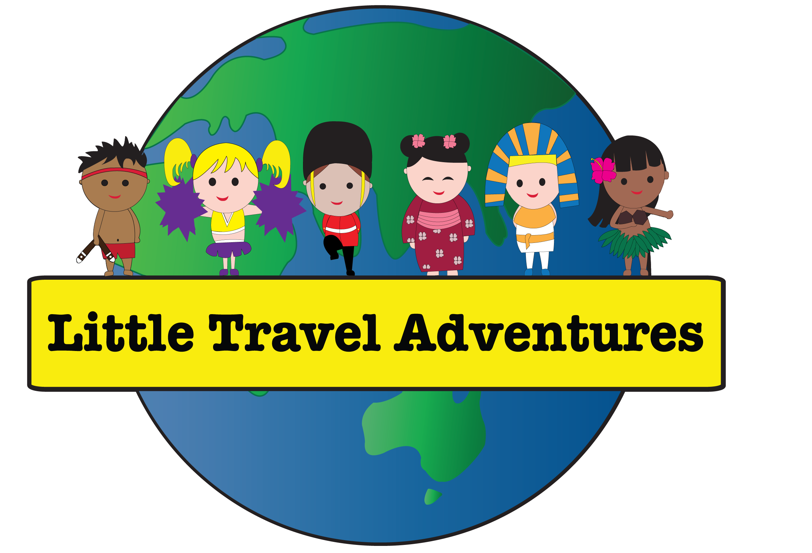

Little Travel Adventures

**Statement of Commitment to Child Safety**

When Little Travel adventures visits a child care centre, every child has the right to be safe and feel safe throughout the duration of the class. We commit to the safety and wellbeing of every child in our classes.

To keep children safe, we commit to:

* following the [10 Child Safe Standards](https://ocg.nsw.gov.au/child-safe-scheme/why-we-have-child-safe-standards) whenever on childcare grounds
* providing a safe and supportive space for all children whilst at the center
* making sure that children are not exposed to any form of harmful conduct or abuse whilst participating in Little Travel Adventures programs
* empowering children to participate in decisions that affect them and share any concerns they may have
* encouraging children to approach center staff if they feel unsafe or have any child safety concerns.

As a child safe organisation, we commit to:

* educating everyone involved in our organisation about what it means to be a child safe organisation, so that we can prevent, detect and effectively respond to child abuse, and report if it is observed whilst in our presence
* making sure everyone involved in our organisation knows how to appropriately respond to complaints, allegations, disclosures and breaches to our Child Safe Code of Conduct
* welcoming feedback to continuously improve our child safe policies, procedures and practices
* making sure that when family and community members interact with our organisation, they are aware that child safety is everyone’s responsibility, and their behaviour aligns with our child safe practices.