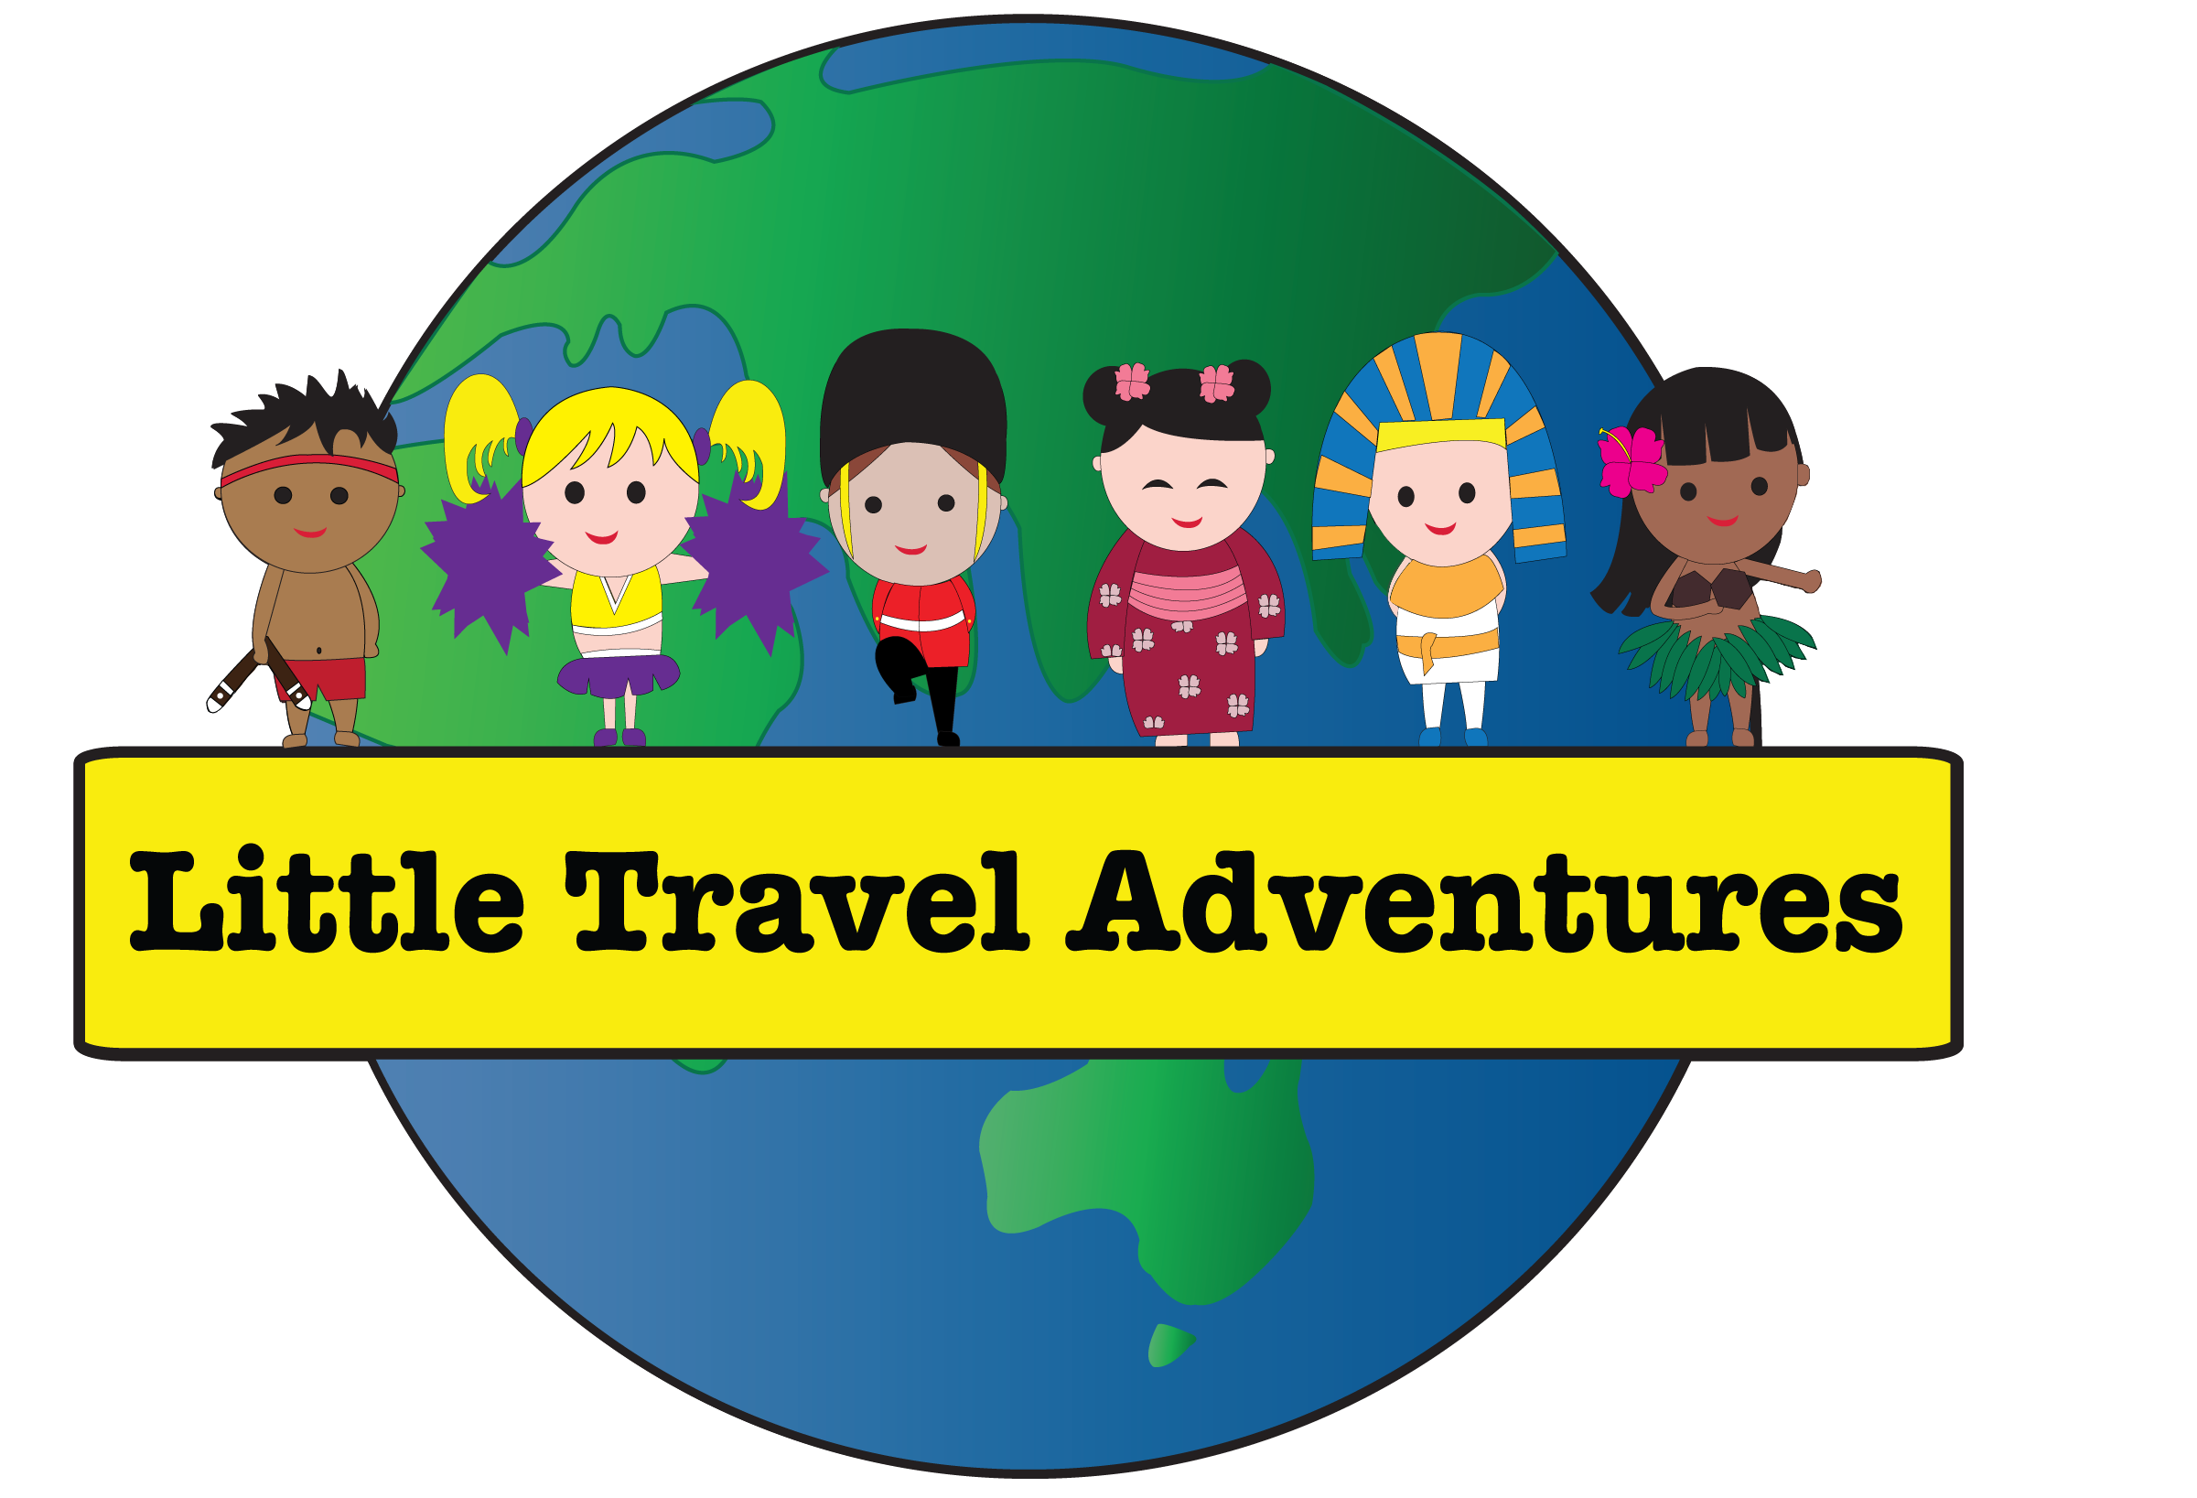

Little Travel Adventures

**Child Safe Risk Management Plan**

## Purpose of plan

Creating a child safe environment includes:

1. identifying environmental risks to children’s safety in relation to the activities and services we provide, our physical settings and our online spaces and communication
2. taking action to reduce these risks and children’s exposure to harm or abuse.

These risks can change over time if our physical and online spaces change, or different activities or services are provided by our organisation. Our plan will be regularly reviewed and updated to reflect any changes.

Our Risk Management Plan in the table below sets out these risks, assesses their potential impact, the strategies to help prevent or reduce them, and keeps track of our progress.

## Nature of our settings and services provided

Little Travel Adventures provides Multicultural entertainment incursions to children.

These activities and services take place in child care centres within the Greater Sydney area, or outside Sydney upon request.

## Responsibility for Risk Management Plan

Kristy Filewood is responsible for making sure that the strategies to manage risks are implemented and monitored.

This version of the plan was completed on 10/01/2025

Everyone in our organisation should be alert to any risks to children’s safety and draw attention to any concerns that may arise, as set out in our Child Safe Policy.

Our Risk Management Plan is available on our website www.littletraveladventures.com.au

## Next review date

Kristy Filewood will review this plan annually on 10/01/2026.

The plan will be reviewed and updated immediately if there are:

* any incidents involving children
* any changes to our physical or online spaces or online communications
* any changes to the types of activities and services involving children that we deliver, including unique events on or off-site.

## Risk assessment matrix

Determine the overall level of risk using the risk matrix table.

Table 1 Risk assessment matrix

|  |  |  |  |  |  |
| --- | --- | --- | --- | --- | --- |
| Likelihood | Insignificant impact | Minor impact | Moderate impact | Major impact | Severe impact |
| Almost certain | Medium | High | Very high | Very high | Very high |
| Likely | Medium | High | High | Very high | Very high |
| Possible | Low | Medium | High | High | Very high |
| Unlikely | Low | Low | Medium | Medium | High |
| Rare | Low | Low | Low | Low | Medium |

For more information and guidance, staff responsible for developing, reviewing and updating our Child Safe Risk Management Plan can read the OCG’s [handbooks on risk management](https://ocg.nsw.gov.au/resources?combine=&field_published_date_value=&field_topic_target_id%5B35%5D=35&field_resource_doc_type_target_id%5B21%5D=21), watch the [OCG and Office of Sport video](https://www.youtube.com/watch?v=zUyeG0cNFz4), or sign up for the OCG’s [training](https://ocg.nsw.gov.au/events) to help your organisation develop its Child Safe Risk Management